Name: Dhruv Jain Rollno.: 180020006
Digital Systems (EE 204) Assignment-1
Project Link for all VHDL Files :-
https://github.com/Feetly/Course_Projects/tree/master/11.%20ModelSim%20Projects

Q.1 Write a VHDL code to design an arithmetic and logic unit using logic gates that performs the following three operations:
1. 4-bit addition
2. 4-bit subtraction
3. 4-bit multiplication
Write a test bench that includes 10 input combinations for the above program.
A.1 => Inputs A, B, S. Output R. S = 00 (add), S = 01 (Sub), S = 10 (Multiply), S = 11( Concate)
Code: -

library IEEE;
use IEEE.STD_LOGIC_1164.ALL;
use IEEE.NUMERIC_STD.ALL;

entity full_sub is
Port(
A : in STD_LOGIC;
B : in STD_LOGIC;
Cin : in STD_LOGIC;
S : out STD_LOGIC;
Cout : out STD_LOGIC);
end full_sub;

architecture dataflow of full_sub is
begin

S <= A XOR B XOR Cin ;
Cout <= ((not A) AND B) OR (Cin AND (not A)) OR (Cin AND B) ;

end dataflow;

library IEEE;
use IEEE.STD_LOGIC_1164.ALL;
use IEEE.NUMERIC_STD.ALL;

entity full_adder is
Port(
A : in STD_LOGIC;
B : in STD_LOGIC;
Cin : in STD_LOGIC;
S : out STD_LOGIC;
Cout : out STD_LOGIC);
end full_adder;

architecture dataflow of full_adder is
begin

S <= A XOR B XOR Cin ;
Cout <= (A AND B) OR (Cin AND A) OR (Cin AND B) ;

end dataflow;

library IEEE;
use IEEE.STD_LOGIC_1164.ALL;
use IEEE.NUMERIC_STD.ALL;

entity Multiplier is
port(
A,B: in std_logic_vector(3 downto 0);
R: out std_logic_vector(7 downto 0)
);
end entity Multiplier;

architecture Behavioral of Multiplier is
begin

R <= std_logic_vector(unsigned(A) * unsigned(B));

end architecture Behavioral;

library IEEE;
use IEEE.STD_LOGIC_1164.ALL;
use IEEE.NUMERIC_STD.ALL;

entity calc is
Port(
A : in std_logic_vector(3 downto 0);
B : in std_logic_vector(3 downto 0);
S : in std_logic_vector(1 downto 0);
R : out std_logic_vector(7 downto 0));
end calc;

architecture Behavioral of calc is

component full_adder
Port(
A : in STD_LOGIC;
B : in STD_LOGIC;
Cin : in STD_LOGIC;
S : out STD_LOGIC;
Cout : out STD_LOGIC);
end component;

component full_sub
Port(
A : in STD_LOGIC;
B : in STD_LOGIC;
Cin : in STD_LOGIC;
S : out STD_LOGIC;
Cout : out STD_LOGIC);
end component;

COMPONENT Multiplier
port(
A , B: in std_logic_vector(3 downto 0);
R: out std_logic_vector(7 downto 0)
);
END COMPONENT;

signal RA : std_logic_vector(7 downto 0) := (others => '0');
signal RS : std_logic_vector(7 downto 0) := (others => '0');
signal RM : std_logic_vector(7 downto 0) := (others => '0');
signal tmp : std_logic := '0';
signal c1,c2,c3: STD_LOGIC;
signal f1,f2,f3: STD_LOGIC;

begin

FS1: full_sub port map( A(0), B(0), tmp, RS(0), f1);
FS2: full_sub port map( A(1), B(1), f1, RS(1), f2);
FS3: full_sub port map( A(2), B(2), f2, RS(2), f3);
FS4: full_sub port map( A(3), B(3), f3, RS(3), RS(4));

M1 : Multiplier port map(A,B,RM);

FA1: full_adder port map( A(0), B(0), tmp, RA(0), c1);
FA2: full_adder port map( A(1), B(1), c1, RA(1), c2);
FA3: full_adder port map( A(2), B(2), c2, RA(2), c3);
FA4: full_adder port map( A(3), B(3), c3, RA(3), RA(4));

process (S,RA,RS,RM,A,B)
begin
if S = "00" then
R <= RA;
elsif S = "01" then
R <= RS;
elsif S = "10" then
R <= RM;
else
R(0) <= B(0);
R(1) <= B(1);
R(2) <= B(2);
R(3) <= B(3);
R(4) <= A(0);
R(5) <= A(1);
R(6) <= A(2);
R(7) <= A(3);
end if;
end process;
end Behavioral;

Test Banch Code:-
library ieee;
use ieee.std_logic_1164.all;

entity calc_tb is
end calc_tb;

architecture behavior OF calc_tb is

COMPONENT calc
Port(
A : in std_logic_vector(3 downto 0);
B : in std_logic_vector(3 downto 0);
S : in std_logic_vector(1 downto 0);
R : out std_logic_vector(7 downto 0));
END COMPONENT;

signal A_tb : std_logic_vector(3 downto 0) := (others => '0');
signal B_tb : std_logic_vector(3 downto 0) := (others => '0');
signal S_tb : std_logic_vector(1 downto 0) := (others => '0');
signal R_tb : std_logic_vector(7 downto 0);

BEGIN

uut: calc PORT MAP (
A => A_tb,
B => B_tb,
S => S_tb,
R => R_tb
);

process
begin

S_tb <= "00";
A_tb <= "1111";
B_tb <= "1111";

wait for 100 ns;
S_tb <= "01";
A_tb <= "1111";
B_tb <= "1111";

wait for 100 ns;
S_tb <= "10";
A_tb <= "1111";
B_tb <= "1111";

wait for 100 ns;
S_tb <= "11";
A_tb <= "1111";
B_tb <= "1111";

wait for 100 ns;
S_tb <= "00";
A_tb <= "1001";
B_tb <= "1010";

wait for 100 ns;
S_tb <= "01";
A_tb <= "1001";
B_tb <= "1010";

wait for 100 ns;
S_tb <= "10";
A_tb <= "1001";
B_tb <= "1010";

wait for 100 ns;
S_tb <= "11";
A_tb <= "1001";
B_tb <= "1010";

wait for 100 ns;

S_tb <= "00";
A_tb <= "1100";
B_tb <= "0011";

wait for 100 ns;
S_tb <= "01";
A_tb <= "1101";
B_tb <= "0010";

wait for 100 ns;
S_tb <= "10";
A_tb <= "1011";
B_tb <= "1011";

wait for 100 ns;
S_tb <= "11";
A_tb <= "0111";
B_tb <= "1110";

wait for 100 ns;
wait;

end process;

END;

Output:

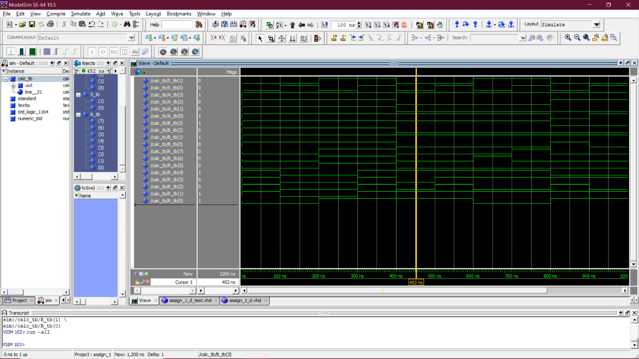

Q.2 Write a VHDL code generates parity as 1 if the number of 1’s a 4-bit long binary message is even and generates 0 otherwise. Use logic gates to design such parity generator. Also, write a VHDL code designing a circuit for parity checker which consider the 5-bit long binary signal (4-bit message + 1-bit parity) and generates 1 if the number of 1’s in the 5-bit binary signal is even and 0 otherwise.
Motivation: If the parity checker generates ‘1’ that means the message signal has error in it. Assumption: Noise can change only 1-bit of the signal
A.2 =>
Part 1: 4-bit parity checker
library IEEE;
use IEEE.STD_LOGIC_1164.ALL;
use IEEE.NUMERIC_STD.ALL;

entity parity is
port(
A: in std_logic_vector(3 downto 0);
R: out std_logic
);
end entity parity;

architecture Behavioral of parity is
begin

R <= NOT(A(3) XOR A(2) XOR A(1) XOR A(0));

end architecture Behavioral;

Test Bench:
library ieee;
use ieee.std_logic_1164.all;

entity parity_tb is
end parity_tb;

architecture behavior OF parity_tb is

COMPONENT parity
port(
A: in std_logic_vector(3 downto 0);
R: out std_logic
);
END COMPONENT;

signal A_tb : std_logic_vector(3 downto 0) := (others => '0');
signal R_tb : std_logic;

BEGIN

uut: parity PORT MAP (
A => A_tb,
R => R_tb
);

process
begin

A_tb <= "0000";

wait for 100 ns;
A_tb <= "0001";

wait for 100 ns;
A_tb <= "0010";

wait for 100 ns;
A_tb <= "0011";

wait for 100 ns;
A_tb <= "0100";

wait for 100 ns;
A_tb <= "0101";

wait for 100 ns;
A_tb <= "0111";

wait for 100 ns;
A_tb <= "1000";

wait for 100 ns;
A_tb <= "1010";

wait for 100 ns;
A_tb <= "1111";

wait for 100 ns;
wait;

end process;

END;

Output:

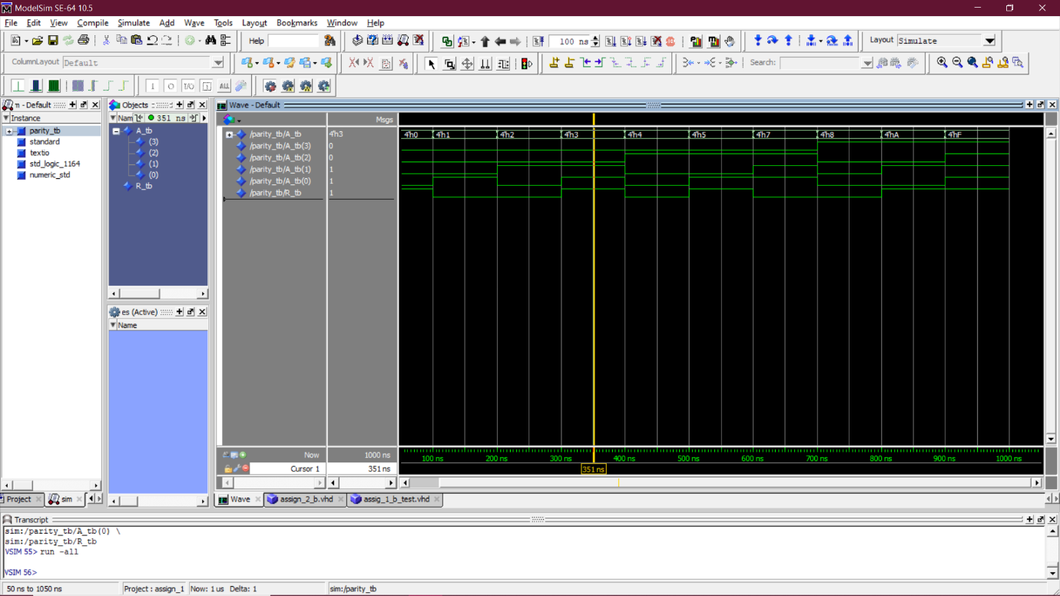

Part 2: 5-bit parity adder
library IEEE;
use IEEE.STD_LOGIC_1164.ALL;
use IEEE.NUMERIC_STD.ALL;

entity parity2 is
port(
A: in std_logic_vector(3 downto 0);
R: out std_logic
);
end entity parity2;

architecture Behavioral of parity2 is
signal B : std_logic;
begin

B <= NOT(A(3) XOR A(2) XOR A(1) XOR A(0));
R <= NOT(B XOR A(3) XOR A(2) XOR A(1) XOR A(0));

end architecture Behavioral;

Test Bench:
library ieee;
use ieee.std_logic_1164.all;

entity parity2_tb is
end parity2_tb;

architecture behavior OF parity2_tb is

COMPONENT parity2
port(
A: in std_logic_vector(3 downto 0);
R: out std_logic
);
END COMPONENT;

signal A_tb : std_logic_vector(3 downto 0) := (others => '0');
signal R_tb : std_logic;

BEGIN

uut: parity2 PORT MAP (
A => A_tb,
R => R_tb
);

process
begin

A_tb <= "0000";

wait for 100 ns;
A_tb <= "0001";

wait for 100 ns;
A_tb <= "0010";

wait for 100 ns;
A_tb <= "0011";

wait for 100 ns;
A_tb <= "0100";

wait for 100 ns;
A_tb <= "0101";

wait for 100 ns;
A_tb <= "0111";

wait for 100 ns;
A_tb <= "1000";

wait for 100 ns;
A_tb <= "1010";

wait for 100 ns;
A_tb <= "1111";

wait for 100 ns;
wait;

end process;

END;

Output:

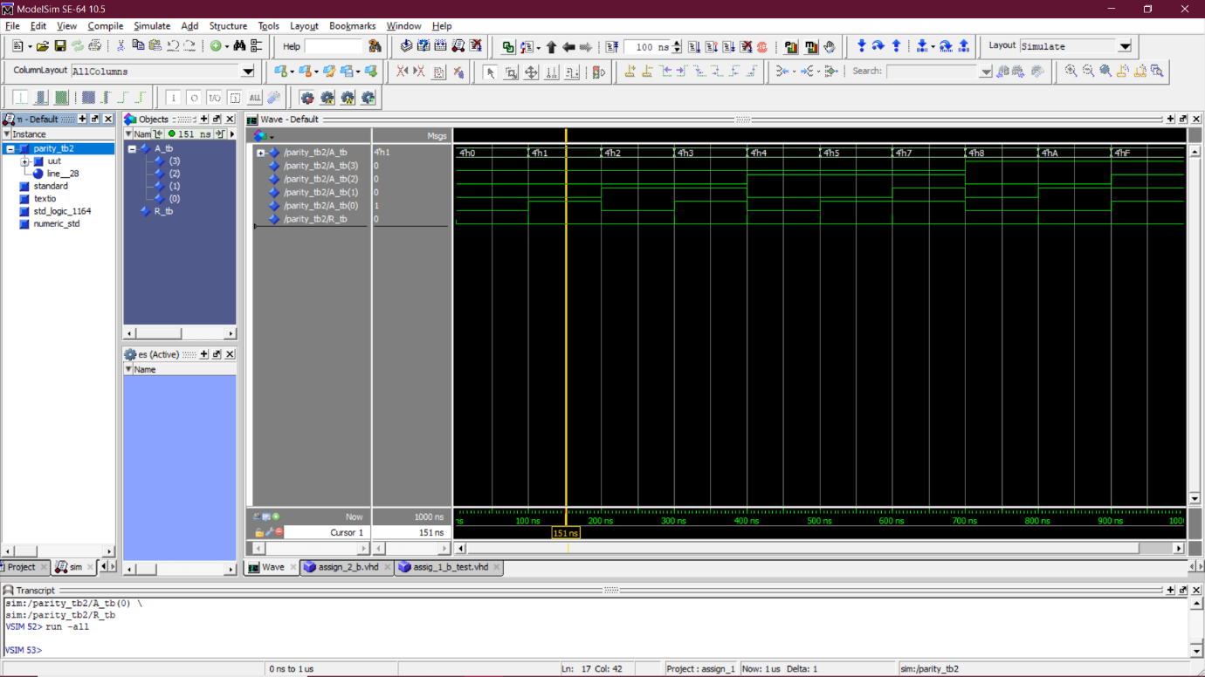

Q.3 Write a VHDL code for a 4X1 MUX. Write a test bench and observe the output. Implement the following function using the 4X1 MUX as component in the code.
𝐹(𝐴,𝐵,𝐶,𝐷) = ∑(1,2,4,7,10,12,14,15)

A.3 =>
Part 1: 4X1 MUX
library IEEE;
use IEEE.STD_LOGIC_1164.ALL;
use IEEE.STD_LOGIC_ARITH.ALL;
use IEEE.STD_LOGIC_UNSIGNED.ALL;

entity MUX is
Port(
S : in STD_LOGIC_VECTOR (1 downto 0);
I : in STD_LOGIC_VECTOR (3 downto 0);
Y : out STD_LOGIC);
end MUX;

architecture Behavioral of MUX is
begin

process (S,I)
begin
if (S <= "00") then
Y <= I(0);

elsif (S <= "01") then
Y <= I(1);

elsif (S <= "10") then
Y <= I(2);

else
Y <= I(3);

end if;
end process;
end Behavioral;

Test Bench:
library ieee;
use ieee.std_logic_1164.all;

entity MUX_tb is
end MUX_tb;

architecture behavior OF MUX_tb is

COMPONENT MUX
Port(
S : in STD_LOGIC_VECTOR (1 downto 0);
I : in STD_LOGIC_VECTOR (3 downto 0);
Y : out STD_LOGIC);

END COMPONENT;

signal S_tb : std_logic_vector(1 downto 0) := (others => '0');
signal I_tb : std_logic_vector(3 downto 0) := (others => '0');
signal Y_tb : std_logic;
BEGIN

uut: MUX PORT MAP (
S => S_tb,
I => I_tb,
Y => Y_tb
);

process
begin

S_tb <= "00";
I_tb <= "0000";

wait for 100 ns;
S_tb <= "01";
I_tb <= "0000";

wait for 100 ns;
S_tb <= "10";
I_tb <= "0000";

wait for 100 ns;
S_tb <= "11";
I_tb <= "0000";

wait for 100 ns;
S_tb <= "00";
I_tb <= "1001";

wait for 100 ns;
S_tb <= "01";
I_tb <= "0111";

wait for 100 ns;
S_tb <= "10";
I_tb <= "0001";

wait for 100 ns;
S_tb <= "11";
I_tb <= "1010";

wait for 100 ns;
S_tb <= "11";
I_tb <= "0111";

wait for 100 ns;
S_tb <= "01";
I_tb <= "1111";

wait for 100 ns;
wait;

end process;

END;

Output:

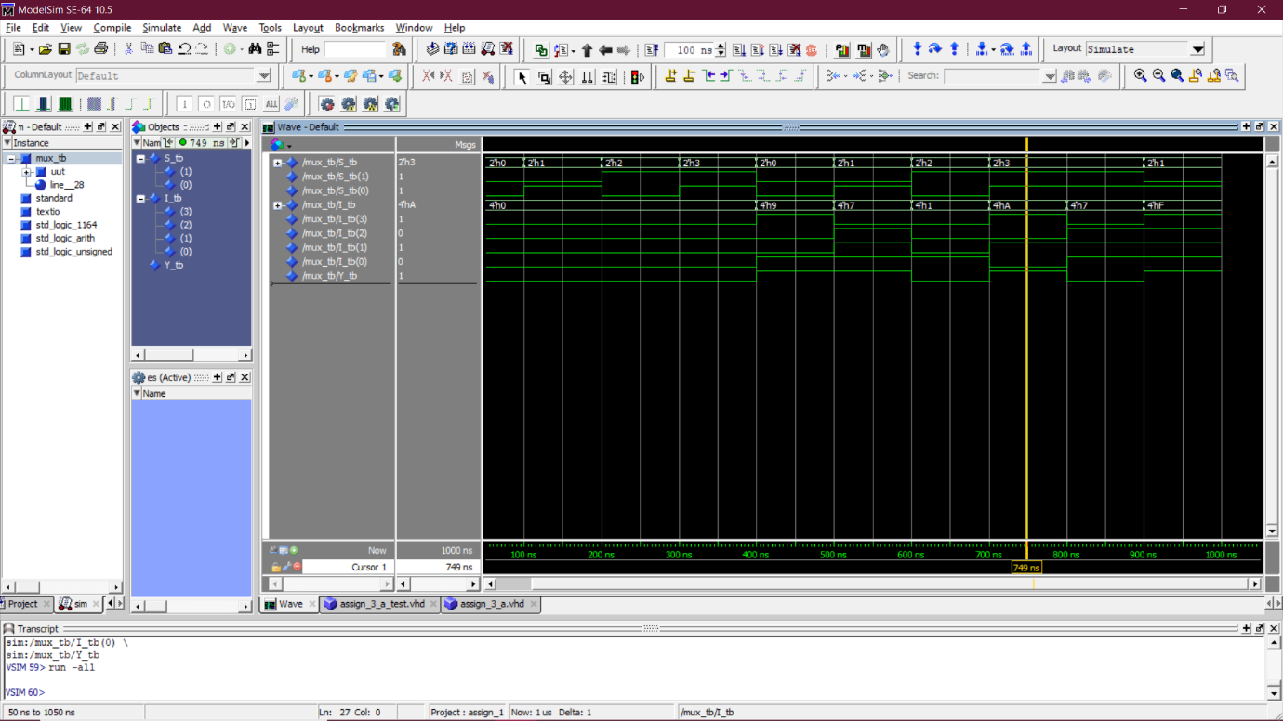

Part 2: Implementing function
library IEEE;
use IEEE.STD_LOGIC_1164.ALL;
use IEEE.STD_LOGIC_ARITH.ALL;
use IEEE.STD_LOGIC_UNSIGNED.ALL;

entity MUXX is
Port(
S1 : in STD_LOGIC;
S0 : in STD_LOGIC;
I3 : in STD_LOGIC;
I2 : in STD_LOGIC;
I1 : in STD_LOGIC;
I0 : in STD_LOGIC;
Y : out STD_LOGIC);
end MUXX;
architecture Behavioral of MUXXis
begin
process (S1,S0,I3,I2,I1,I0)
begin
if (S1 = '0' AND S0 = '0') then
Y <= I0;
elsif (S1 = '0' AND S0 = '1') then
Y <= I1;
elsif (S1 = '1' AND S0 = '0') then
Y <= I2;
else
Y <= I3;
end if;
end process;
end Behavioral;

library ieee;
use ieee.std_logic_1164.all;

entity Func is
Port(
A : in STD_LOGIC;
B : in STD_LOGIC;
C : in STD_LOGIC;
D : in STD_LOGIC;
Y0 : out STD_LOGIC);
end Func;

architecture Behavioral of Func is

component MUXX
Port(
S1 : in STD_LOGIC;
S0 : in STD_LOGIC;
I3 : in STD_LOGIC;
I2 : in STD_LOGIC;
I1 : in STD_LOGIC;
I0 : in STD_LOGIC;
Y : out STD_LOGIC);
end component;

signal I1,I2,I3,I0: std_logic;
begin

I0 <= C xor D;
I1 <= C xnor D;
I2 <= C and (not D);
I3 <= C or (not D);

uut: MUXX port map( A , B, I3 , I2 , I1 , I0 , Y0 );

end Behavioral;

Test Bench:
library ieee;
use ieee.std_logic_1164.all;

entity Func_tb is
end Func_tb;

architecture behavior OF Func_tb is

COMPONENT Func
Port(
A : in STD_LOGIC;
B : in STD_LOGIC;
C : in STD_LOGIC;
D : in STD_LOGIC;
Y0 : out STD_LOGIC);

END COMPONENT;

signal A_tb : std_logic := '0';
signal B_tb : std_logic := '0';
signal C_tb : std_logic := '0';
signal D_tb : std_logic := '0';
signal Y0_tb : std_logic;

BEGIN

uut: Func PORT MAP (
A => A_tb,
B => B_tb,
C => C_tb,
D => D_tb,
Y0 => Y0_tb
);

process
begin

A_tb <= '0'; B_tb <= '0'; C_tb <= '0'; D_tb <= '0';

wait for 100 ns;
A_tb <= '0'; B_tb <= '0'; C_tb <= '0'; D_tb <= '1';

wait for 100 ns;
A_tb <= '0'; B_tb <= '0'; C_tb <= '1'; D_tb <= '1';

wait for 100 ns;
A_tb <= '1'; B_tb <= '0'; C_tb <= '0'; D_tb <= '0';

wait for 100 ns;
A_tb <= '0'; B_tb <= '0'; C_tb <= '0'; D_tb <= '1';

wait for 100 ns;
A_tb <= '0'; B_tb <= '1'; C_tb <= '0'; D_tb <= '1';

wait for 100 ns;
A_tb <= '0'; B_tb <= '1'; C_tb <= '1'; D_tb <= '0';

wait for 100 ns;
A_tb <= '1'; B_tb <= '0'; C_tb <= '0'; D_tb <= '1';

wait for 100 ns;
A_tb <= '1'; B_tb <= '0'; C_tb <= '1'; D_tb <= '0';

wait for 100 ns;
A_tb <= '1'; B_tb <= '1'; C_tb <= '1'; D_tb <= '1';

wait for 100 ns;
wait;

end process;

END;

Output:

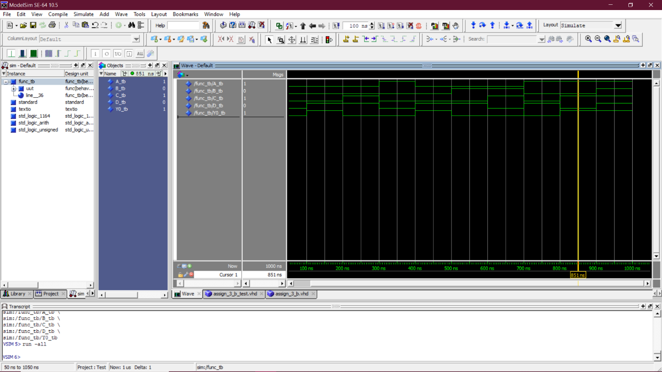

Q.4 Write a VHDL code for a D-flipflop using behavioural modelling. Use the D-Flipflop as a component to design a 4-bit universal shift register that does the following operation:
A B Operation 1 1 Loads Parallel Data 1 0 Circular Left Shift 0 1 Circular Right Shift
Write a testbench along with a suitable clock input to observe the output.

A.4 =>
Part 1: D FlipFlop
library ieee;
use ieee.std_logic_1164.all;

entity D_FlipFlop is
port(
I: in std_logic;
clk: in std_logic;
rst: in std_logic;
prst: in std_logic;
Y: out std_logic);
end D_FlipFlop;

architecture behavioral of D_FlipFlop is
begin
process(prst,rst,clk,I)
begin
if (rst='1') then
Y <= '0';
elsif (prst='1') then
Y <= '1' ;
elsif(rising_edge(clk)) then
Y <= I;
end if;
end process;

end behavioral;

Test Bench:
LIBRARY ieee;
USE ieee.std_logic_1164.ALL;

ENTITY D_FlipFlop_tb IS
END D_FlipFlop_tb;

ARCHITECTURE behavior OF D_FlipFlop_tb IS

COMPONENT D_FlipFlop
port(
I: in std_logic;
clk: in std_logic;
rst: in std_logic;
prst: in std_logic;
Y: out std_logic);
END COMPONENT;

signal I_tb : std_logic := '0';
signal clk_tb : std_logic := '0';
signal rst_tb : std_logic := '1';
signal prst_tb : std_logic := '0';
signal Y_tb : std_logic;

constant clk_period : time := 20 ns;
signal ctr : integer := 0;

BEGIN

uut: D_FlipFlop PORT MAP (
I => I_tb,
clk => clk_tb,
rst => rst_tb,
prst => prst_tb,
Y => Y_tb
);

clk_process :process
begin
clk_tb <= '0';
wait for clk_period/2;
clk_tb <= '1';
wait for clk_period/2;
ctr <= ctr+20;
if (ctr = 380) then
wait;
end if;
end process;

stim_proc: process
begin

rst_tb <= '1';
prst_tb <= '0';
wait for 100 ns;

rst_tb <= '0';
prst_tb <= '1';
wait for 100 ns;

rst_tb <= '0';
prst_tb <= '0';
I_tb <= '0';
wait for 100 ns;

rst_tb <= '0';
prst_tb <= '0';
I_tb <= '1';

wait for 100 ns;
wait;

end process;

END;

Output:
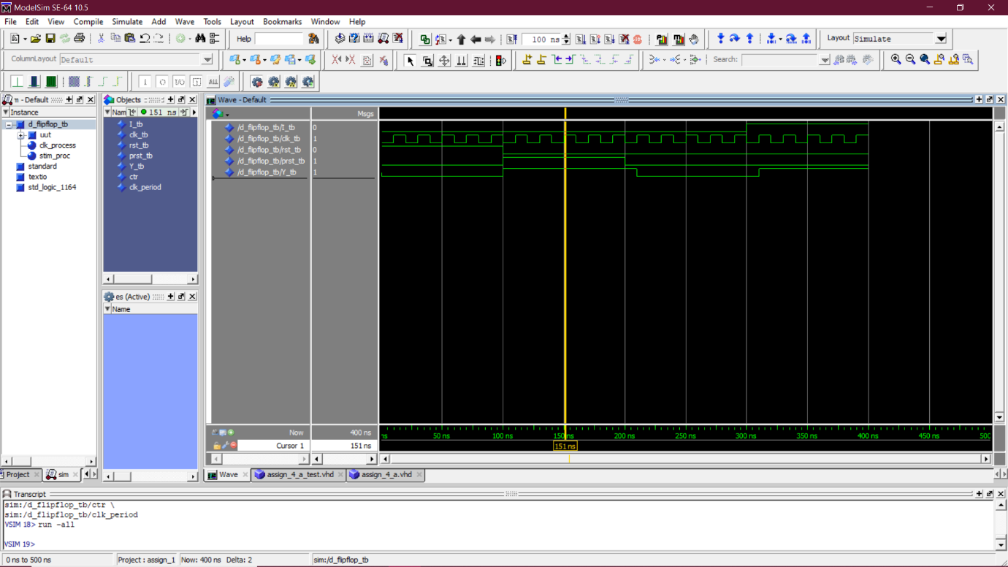

Part 2: Circular Register
library ieee;
use ieee.std_logic_1164.all;

entity D_FlipFlop is
port(
I: in std_logic;
clk: in std_logic;
rst: in std_logic;
prst: in std_logic;
YD: out std_logic);
end D_FlipFlop;

architecture behavioral of D_FlipFlop is
begin
process(prst,rst,clk,I)
begin
if (rst='1') then
YD <= '0';
elsif (prst='1') then
YD <= '1' ;
elsif(rising_edge(clk)) then
YD <= I;
end if;
end process;

end behavioral;

library IEEE;
use IEEE.STD_LOGIC_1164.ALL;
use IEEE.STD_LOGIC_ARITH.ALL;
use IEEE.STD_LOGIC_UNSIGNED.ALL;

entity MUX is
Port(
S1 : in STD_LOGIC;
S0 : in STD_LOGIC;
I3 : in STD_LOGIC;
I2 : in STD_LOGIC;
I1 : in STD_LOGIC;
I0 : in STD_LOGIC;
YM : out STD_LOGIC);
end MUX;

architecture Behavioral of MUX is
begin
process (S1,S0,I3,I2,I1,I0)
begin
if (S1 = '0' AND S0 = '0') then
YM <= I0;
elsif (S1 = '0' AND S0 = '1') then
YM <= I1;
elsif (S1 = '1' AND S0 = '0') then
YM <= I2;
else
YM <= I3;
end if;
end process;
end Behavioral;

library ieee;
use ieee.std_logic_1164.all;

entity Cir_Register is
Port(
Inp : in std_logic_vector(3 downto 0);
Q: out std_logic_vector(3 downto 0);
S : in std_logic_vector(1 downto 0);
clck: in std_logic);
end Cir_Register;

architecture Behavioral of Cir_Register is

component D_FlipFlop
port(
I: in std_logic;
clk: in std_logic;
rst: in std_logic;
prst: in std_logic;
YD: out std_logic);
end component;

component MUX
Port(
S1 : in STD_LOGIC;
S0 : in STD_LOGIC;
I3 : in STD_LOGIC;
I2 : in STD_LOGIC;
I1 : in STD_LOGIC;
I0 : in STD_LOGIC;
YM : out STD_LOGIC);
end component;

signal Y : std_logic_vector(3 downto 0) := (others => '0');
signal QM : std_logic_vector(3 downto 0) := (others => '0');
begin

M3: MUX port map( S(1) , S(0), Inp(3) , QM(2) , QM(0) , '0' , Y(3) );
M2: MUX port map( S(1) , S(0), Inp(2) , QM(1) , QM(3) , '0' , Y(2) );
M1: MUX port map( S(1) , S(0), Inp(1) , QM(0) , QM(2) , '0' , Y(1) );
M0: MUX port map( S(1) , S(0), Inp(0) , QM(3) , QM(1) , '0' , Y(0) );

D3: D_FlipFlop PORT MAP( Y(3) , clck , '0' , '0' , QM(3));
D2: D_FlipFlop PORT MAP( Y(2) , clck , '0' , '0' , QM(2));
D1: D_FlipFlop PORT MAP( Y(1) , clck , '0' , '0' , QM(1));
D0: D_FlipFlop PORT MAP( Y(0) , clck , '0' , '0' , QM(0));

Q <= QM;

end Behavioral;

--------------------------------------------------------------------------------------------------------------------------------------------------
Test Bench:

LIBRARY ieee;
USE ieee.std_logic_1164.ALL;

ENTITY Cir_Register_tb IS
END Cir_Register_tb;

ARCHITECTURE behavior OF Cir_Register_tb IS

COMPONENT Cir_Register
Port(
Inp : in std_logic_vector(3 downto 0);
Q: out std_logic_vector(3 downto 0);
S : in std_logic_vector(1 downto 0);
clck: in std_logic);
END COMPONENT;

signal Inp_tb : std_logic_vector(3 downto 0) := (others => '0');
signal S_tb : std_logic_vector(1 downto 0) := (others => '0');
signal Q_tb: std_logic_vector(3 downto 0);
signal clck_tb: std_logic := '0';

constant clk_period : time := 20 ns;
signal ctr : integer := 0;

BEGIN

uut: Cir_Register PORT MAP(
Inp => Inp_tb,
clck => clck_tb,
S => S_tb,
Q => Q_tb
);

clck_process :process
begin
clck_tb <= '0';
wait for clk_period/2;
clck_tb <= '1';
wait for clk_period/2;
ctr <= ctr+20;
if (ctr = 480) then
wait;
end if;
end process;

stim_proc: process
begin

S_tb <= "11";
Inp_tb <= "1000";
wait for 50 ns;

S_tb <= "01";
wait for 100 ns;

S_tb <= "10";
wait for 100 ns;

S_tb <= "11";
Inp_tb <= "1001";
wait for 50 ns;

S_tb <= "01";
wait for 100 ns;

S_tb <= "10";
wait for 100 ns;
wait;

end process;

END;

Output:

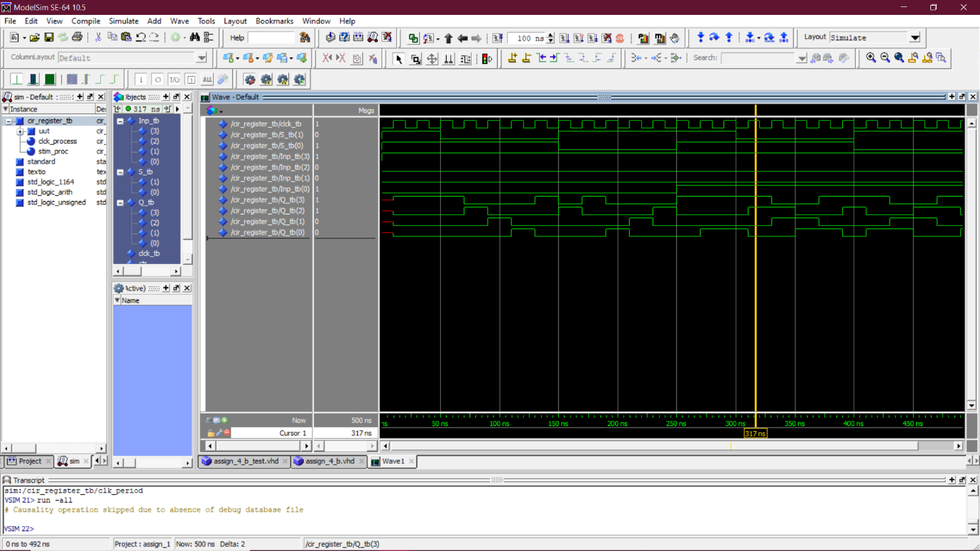

Extras:
1. 4-bit Adder
Code
library ieee;
use ieee.std_logic_1164.all; -- Highlights

entity full_adder is
Port(
A : in STD_LOGIC;
B : in STD_LOGIC;
Cin : in STD_LOGIC;
S : out STD_LOGIC;
Cout : out STD_LOGIC);
end full_adder;

architecture dataflow of full_adder is
begin

S <= A XOR B XOR Cin ;
Cout <= (A AND B) OR (Cin AND A) OR (Cin AND B) ;

end dataflow;

library ieee;
use ieee.std_logic_1164.all; -- Highlights

entity adder is
Port ( A3 : in STD_LOGIC;
A2 : in STD_LOGIC;
A1 : in STD_LOGIC;
A0 : in STD_LOGIC;
B3 : in STD_LOGIC;
B2 : in STD_LOGIC;
B1 : in STD_LOGIC;
B0 : in STD_LOGIC;
S3 : out STD_LOGIC;
S2 : out STD_LOGIC;
S1 : out STD_LOGIC;
S0 : out STD_LOGIC;
Cout : out STD_LOGIC);
end adder;

architecture Behavioral of adder is

component full_adder
Port ( A : in STD_LOGIC;
B : in STD_LOGIC;
Cin : in STD_LOGIC;
S : out STD_LOGIC;
Cout : out STD_LOGIC);
end component;

signal c1,c2,c3: STD_LOGIC;
signal c0 : std_logic := '0';

begin

FA1: full_adder port map( A0, B0, c0, S0, c1);
FA2: full_adder port map( A1, B1, c1, S1, c2);
FA3: full_adder port map( A2, B2, c2, S2, c3);
FA4: full_adder port map( A3, B3, c3, S3, Cout);

end Behavioral;

Test bench:
library ieee;
use ieee.std_logic_1164.all;

entity adder_tb is
end adder_tb;

architecture behavior OF adder_tb is

COMPONENT adder
Port ( A3 : in STD_LOGIC;
A2 : in STD_LOGIC;
A1 : in STD_LOGIC;
A0 : in STD_LOGIC;
B3 : in STD_LOGIC;
B2 : in STD_LOGIC;
B1 : in STD_LOGIC;
B0 : in STD_LOGIC;
S3 : out STD_LOGIC;
S2 : out STD_LOGIC;
S1 : out STD_LOGIC;
S0 : out STD_LOGIC;
Cout : out STD_LOGIC);
END COMPONENT;

signal a3_tb : std_logic := '0';
signal a2_tb : std_logic := '0';
signal a1_tb : std_logic := '0';
signal a0_tb : std_logic := '0';
signal b3_tb : std_logic := '0';
signal b2_tb : std_logic := '0';
signal b1_tb : std_logic := '0';
signal b0_tb : std_logic := '0';
signal s3_tb : std_logic;
signal s2_tb : std_logic;
signal s1_tb : std_logic;
signal s0_tb : std_logic;
signal cout_tb : std_logic;

BEGIN

uut: adder PORT MAP (
A3 => a3_tb,
A2 => a2_tb,
A1 => a1_tb,
A0 => a0_tb,
B3 => b3_tb,
B2 => b2_tb,
B1 => b1_tb,
B0 => b0_tb,
S3 => s3_tb,
S2 => s2_tb,
S1 => s1_tb,
S0 => s0_tb,
Cout => cout_tb
);

process
begin

a3_tb <= '0'; a2_tb <= '0'; a1_tb <= '0'; a0_tb <= '0';
b3_tb <= '0'; b2_tb <= '0'; b1_tb <= '0'; b0_tb <= '0';

wait for 100 ns;
a3_tb <= '1'; a2_tb <= '1'; a1_tb <= '1'; a0_tb <= '1';
b3_tb <= '0'; b2_tb <= '0'; b1_tb <= '0'; b0_tb <= '0';

wait for 100 ns;
a3_tb <= '1'; a2_tb <= '1'; a1_tb <= '1'; a0_tb <= '1';
b3_tb <= '1'; b2_tb <= '1'; b1_tb <= '1'; b0_tb <= '1';

wait for 100 ns;
a3_tb <= '1'; a2_tb <= '1'; a1_tb <= '1'; a0_tb <= '1';
b3_tb <= '1'; b2_tb <= '0'; b1_tb <= '1'; b0_tb <= '0';

wait for 100 ns;
a3_tb <= '0'; a2_tb <= '0'; a1_tb <= '0'; a0_tb <= '1';
b3_tb <= '1'; b2_tb <= '0'; b1_tb <= '1'; b0_tb <= '1';

wait for 100 ns;
a3_tb <= '0'; a2_tb <= '1'; a1_tb <= '0'; a0_tb <= '1';
b3_tb <= '1'; b2_tb <= '0'; b1_tb <= '0'; b0_tb <= '1';

wait for 100 ns;
a3_tb <= '1'; a2_tb <= '1'; a1_tb <= '1'; a0_tb <= '0';
b3_tb <= '0'; b2_tb <= '1'; b1_tb <= '1'; b0_tb <= '0';

wait for 100 ns;
a3_tb <= '1'; a2_tb <= '1'; a1_tb <= '0'; a0_tb <= '0';
b3_tb <= '1'; b2_tb <= '0'; b1_tb <= '1'; b0_tb <= '0';

wait for 100 ns;
a3_tb <= '0'; a2_tb <= '0'; a1_tb <= '1'; a0_tb <= '1';
b3_tb <= '1'; b2_tb <= '0'; b1_tb <= '1'; b0_tb <= '1';

wait for 100 ns;
a3_tb <= '0'; a2_tb <= '1'; a1_tb <= '0'; a0_tb <= '1';
b3_tb <= '1'; b2_tb <= '0'; b1_tb <= '1'; b0_tb <= '1';

wait for 100 ns;
wait;

end process;

END;

Output:

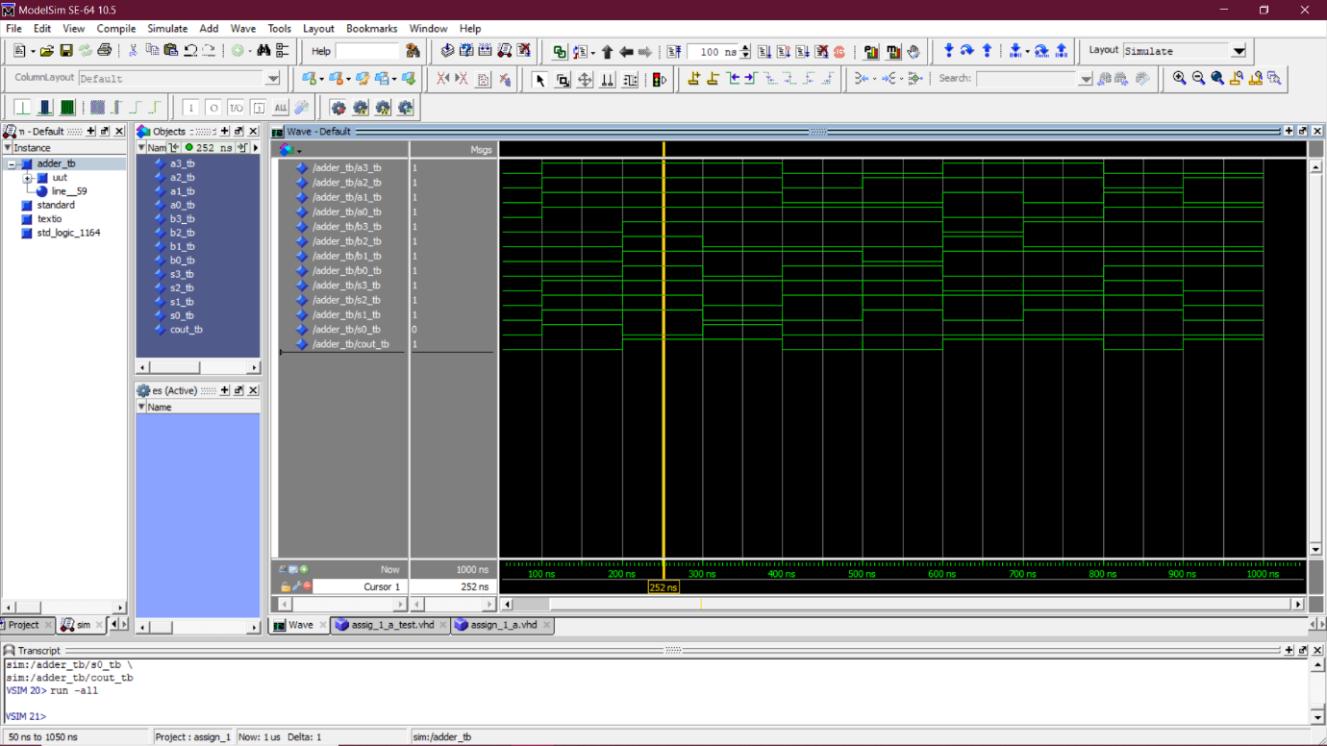

2. 4-bit Subtractor
Code
library ieee;
use ieee.std_logic_1164.all; -- Highlights

entity full_sub is
Port(
A : in STD_LOGIC;
B : in STD_LOGIC;
Cin : in STD_LOGIC;
S : out STD_LOGIC;
Cout : out STD_LOGIC);
end full_sub;

architecture dataflow of full_sub is
begin

S <= A XOR B XOR Cin ;
Cout <= ((not A) AND B) OR (Cin AND (not A)) OR (Cin AND B) ;

end dataflow;

library ieee;
use ieee.std_logic_1164.all; -- Highlights

entity sub is
Port(
A3 : in STD_LOGIC;
A2 : in STD_LOGIC;
A1 : in STD_LOGIC;
A0 : in STD_LOGIC;
B3 : in STD_LOGIC;
B2 : in STD_LOGIC;
B1 : in STD_LOGIC;
B0 : in STD_LOGIC;
S3 : out STD_LOGIC;
S2 : out STD_LOGIC;
S1 : out STD_LOGIC;
S0 : out STD_LOGIC;
Cout : out STD_LOGIC);
end sub;

architecture Behavioral of sub is

component full_sub
Port(
A : in STD_LOGIC;
B : in STD_LOGIC;
Cin : in STD_LOGIC;
S : out STD_LOGIC;
Cout : out STD_LOGIC);
end component;

signal c1,c2,c3: STD_LOGIC;
signal c0 : std_logic := '0';

begin

FS1: full_sub port map( A0, B0, c0, S0, c1);
FS2: full_sub port map( A1, B1, c1, S1, c2);
FS3: full_sub port map( A2, B2, c2, S2, c3);
FS4: full_sub port map( A3, B3, c3, S3, Cout);

end Behavioral;

Test bench:
library ieee;
use ieee.std_logic_1164.all;

entity sub_tb is
end sub_tb;

architecture behavior OF sub_tb is

COMPONENT sub
Port(
A3 : in STD_LOGIC;
A2 : in STD_LOGIC;
A1 : in STD_LOGIC;
A0 : in STD_LOGIC;
B3 : in STD_LOGIC;
B2 : in STD_LOGIC;
B1 : in STD_LOGIC;
B0 : in STD_LOGIC;
S3 : out STD_LOGIC;
S2 : out STD_LOGIC;
S1 : out STD_LOGIC;
S0 : out STD_LOGIC;
Cout : out STD_LOGIC);
END COMPONENT;

signal a3_tb : std_logic := '0';
signal a2_tb : std_logic := '0';
signal a1_tb : std_logic := '0';
signal a0_tb : std_logic := '0';
signal b3_tb : std_logic := '0';
signal b2_tb : std_logic := '0';
signal b1_tb : std_logic := '0';
signal b0_tb : std_logic := '0';
signal s3_tb : std_logic;
signal s2_tb : std_logic;
signal s1_tb : std_logic;
signal s0_tb : std_logic;
signal cout_tb : std_logic;

BEGIN

uut: sub PORT MAP (
A3 => a3_tb,
A2 => a2_tb,
A1 => a1_tb,
A0 => a0_tb,
B3 => b3_tb,
B2 => b2_tb,
B1 => b1_tb,
B0 => b0_tb,
S3 => s3_tb,
S2 => s2_tb,
S1 => s1_tb,
S0 => s0_tb,
Cout => cout_tb
);

process
begin

a3_tb <= '0'; a2_tb <= '0'; a1_tb <= '0'; a0_tb <= '0';
b3_tb <= '0'; b2_tb <= '0'; b1_tb <= '0'; b0_tb <= '0';

wait for 100 ns;
a3_tb <= '1'; a2_tb <= '1'; a1_tb <= '1'; a0_tb <= '1';
b3_tb <= '0'; b2_tb <= '0'; b1_tb <= '0'; b0_tb <= '0';

wait for 100 ns;
a3_tb <= '1'; a2_tb <= '1'; a1_tb <= '1'; a0_tb <= '1';
b3_tb <= '1'; b2_tb <= '1'; b1_tb <= '1'; b0_tb <= '1';

wait for 100 ns;
a3_tb <= '1'; a2_tb <= '1'; a1_tb <= '1'; a0_tb <= '1';
b3_tb <= '1'; b2_tb <= '0'; b1_tb <= '1'; b0_tb <= '0';

wait for 100 ns;
a3_tb <= '0'; a2_tb <= '0'; a1_tb <= '0'; a0_tb <= '1';
b3_tb <= '1'; b2_tb <= '0'; b1_tb <= '1'; b0_tb <= '1';

wait for 100 ns;
a3_tb <= '0'; a2_tb <= '1'; a1_tb <= '0'; a0_tb <= '1';
b3_tb <= '1'; b2_tb <= '0'; b1_tb <= '0'; b0_tb <= '1';

wait for 100 ns;
a3_tb <= '1'; a2_tb <= '1'; a1_tb <= '1'; a0_tb <= '0';
b3_tb <= '0'; b2_tb <= '1'; b1_tb <= '1'; b0_tb <= '0';

wait for 100 ns;
a3_tb <= '1'; a2_tb <= '1'; a1_tb <= '0'; a0_tb <= '0';
b3_tb <= '1'; b2_tb <= '0'; b1_tb <= '1'; b0_tb <= '0';

wait for 100 ns;
a3_tb <= '0'; a2_tb <= '0'; a1_tb <= '1'; a0_tb <= '1';
b3_tb <= '1'; b2_tb <= '0'; b1_tb <= '1'; b0_tb <= '1';

wait for 100 ns;
a3_tb <= '0'; a2_tb <= '1'; a1_tb <= '0'; a0_tb <= '1';
b3_tb <= '1'; b2_tb <= '0'; b1_tb <= '1'; b0_tb <= '1';

wait for 100 ns;
wait;

end process;

END;

Output:

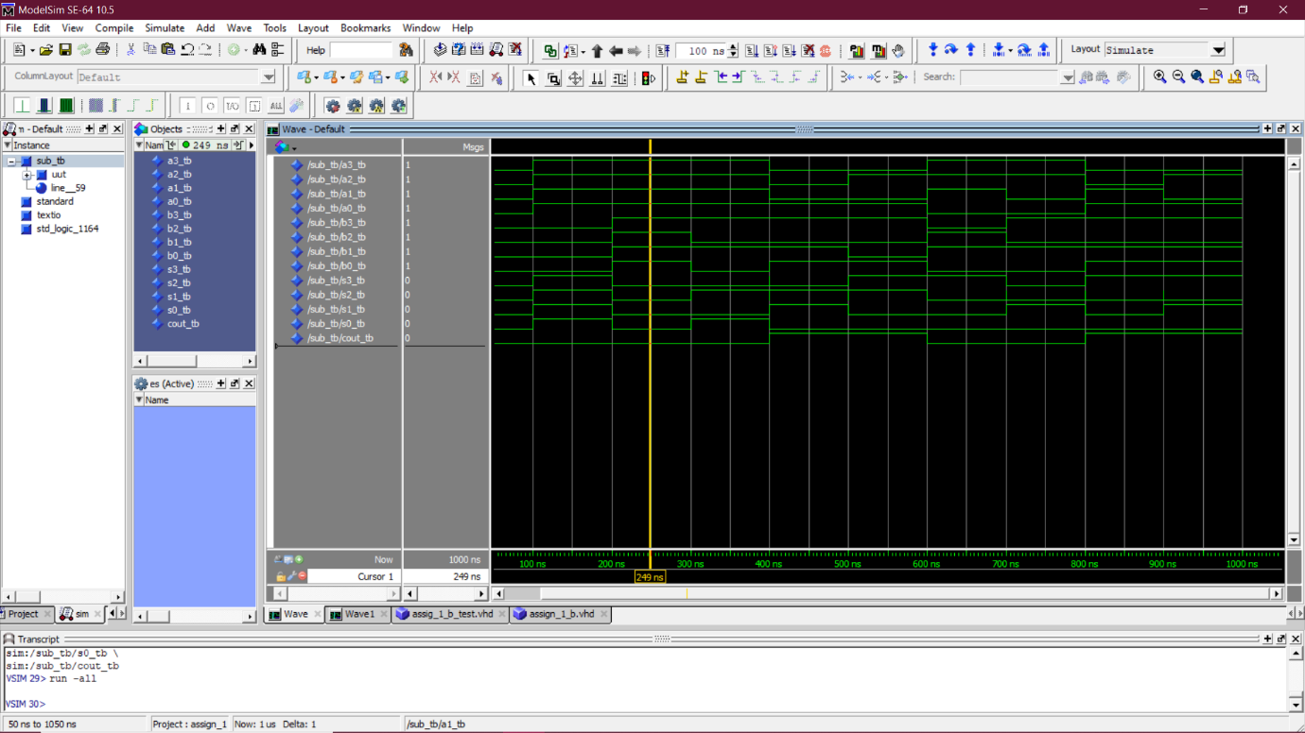

3. 4-bit Multiplier
Code
library IEEE;
use IEEE.STD_LOGIC_1164.ALL;
use IEEE.NUMERIC_STD.ALL;

entity Multiplier is
port(
A , B: in std_logic_vector(3 downto 0);
R: out std_logic_vector(7 downto 0)
);
end entity Multiplier;

architecture Behavioral of Multiplier is
begin

R <= std_logic_vector(unsigned(A) * unsigned(B));

end architecture Behavioral;

Test bench:
library ieee;
use ieee.std_logic_1164.all;

entity Multiplier_tb is
end Multiplier_tb;

architecture behavior OF Multiplier_tb is

COMPONENT Multiplier
port(
A , B: in std_logic_vector(3 downto 0);
R: out std_logic_vector(7 downto 0)
);
END COMPONENT;

signal A_tb : std_logic_vector(3 downto 0) := (others => '0');
signal B_tb : std_logic_vector(3 downto 0) := (others => '0');
signal R_tb : std_logic_vector(7 downto 0);

BEGIN

uut: Multiplier PORT MAP(
A => A_tb,
B => B_tb,
R => R_tb
);

process
begin

A_tb <= "0000";
B_tb <= "0000";

wait for 100 ns;
A_tb <= "1111";
B_tb <= "1111";

wait for 100 ns;
A_tb <= "1111";
B_tb <= "1111";

wait for 100 ns;
A_tb <= "1010";
B_tb <= "0101";

wait for 100 ns;
A_tb <= "1001";
B_tb <= "0110";

wait for 100 ns;
A_tb <= "1100";
B_tb <= "0110";

wait for 100 ns;
A_tb <= "0101";
B_tb <= "0110";

wait for 100 ns;
A_tb <= "0100";
B_tb <= "0101";

wait for 100 ns;
A_tb <= "1110";
B_tb <= "0110";

wait for 100 ns;
A_tb <= "0000";
B_tb <= "0110";

wait for 100 ns;
wait;

end process;

END;

Output:

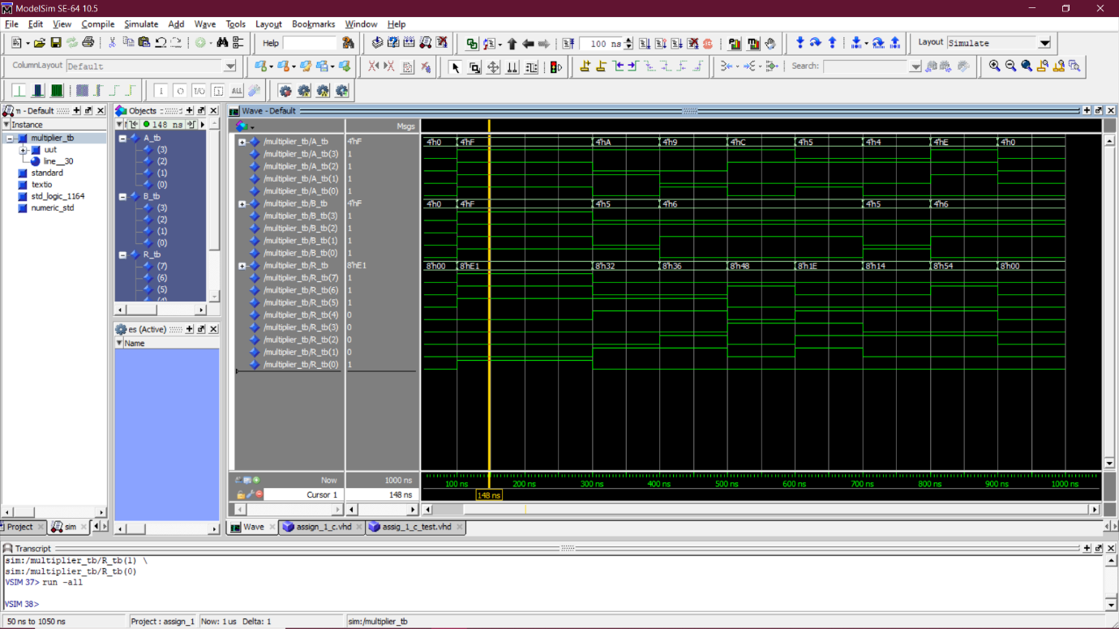

The End

